

Karmaveer Bhaurao Patil College of Engineering,Satara

[A review on piezoelectric material as a source of generating electricity and its possibility to fabricate devices for daily uses of army personnel](https://www.researchgate.net/publication/276171645_A_review_on_piezoelectric_material_as_a_source_of_generating_electricity_and_its_possibility_to_fabricate_devices_for_daily_uses_of_army_personnel?enrichId=rgreq-24efe8d30c85fd4af5abda47aa864e18-XXX&enrichSource=Y292ZXJQYWdlOzI3NjE3MTY0NTtBUzozMDYxMDgwMzg2MTUwNDBAMTQ0OTk5MzI1MTY4Mw%3D%3D&el=1_x_3&_esc=publicationCoverPdf)

 

**4 authors**

Nikhil Mote

Karmaveer Bhaurao Patil College of Engineering,Satara

Rutik Raut

Karmaveer Bhaurao Patil College of Engineering,Satara

Nishant Virkar

Karmaveer Bhaurao Patil College of Engineering,Satara

Viraj Nikam

Karmaveer Bhaurao Patil College of Engineering,Satara

# Prof.Uchale Bhagwat:

Karmaveer Bhaurao Patil College of Engineering,Satara

Email:[uchale.bhagwat@kbpcoes.edu.in](mailto:uchale.bhagwat@kbpcoes.edu.in)



**Piezoelectric Tiles: Solution for Sustainable Energy**

**Harvesting**



**Abstract**: Energy harvesting, a process of capturing ambient waste energy and converting it into usable electricity, has been garnering significant attention due to the limitations of traditional power sources. In our project, we have harnessed this technology by fabricating flexible piezoelectric composite discs. The study investigates the performance of these discs, which incorporate lead zirconate titanate (PZT) powder with particle sizes of 3 µm and 1 µm,multiwalled carbon nanotubes (MWCNT) with diameters of 5–20 nm and lengths up to 10 µm, and polydimethylsiloxane (PDMS) synthetic silicone rubber. Solvents such as THF and chloroform were utilized in the preparation process. The composite discs weretested for their peak performance, lifetime, and durability under various conditions. The primary objective of our research is to extract usable power to operate low-power devices, including mobile devices and wireless sensor networks, and to support the recentadvancements in extremely low-power electrical and mechanical devices such as micro-electromechanical systems (MEMS).

**Keywords**: energy harvesting; piezoelectric material; lead zirconate titanate; PZT; composite; flexible discs; sustainable energy; MWCNT; PDMS; MEMS; project implementation



## Introduction

With rapid strides in the field of microelectronics, electronic devices of daily use are shrinking in size by the day. Moreover, their power requirements are shrinking too. Therefore there is an increasing need to have a portable power source that can power these devices, independent of conventional power sources such as batteries, domestic power supplies, etc. and could be accessible from any corner of the world (Paradiso and Starner, 2005; [http://sroeco.com/solar/most-efficient-solar-panels).](http://sroeco.com/solar/most-efficient-solar-panels)) Lots of efforts have been made previously on energy conversion to convert different forms of energy into electrical energy. There are basically three common mechanisms used for energy scavenging applications which are electrostatic, electromagnetic and piezoelectric [(http://en](http://en.wikipedia.org/wiki/Energy_harvesting)).[wikipedia.org/wiki/Energy_harvesting).](http://en.wikipedia.org/wiki/Energy_harvesting)) In the 90s, researchers turned their attention towards anthropomorphic energy scavenging. In simple terms extraction of energy unobtrusively from human activities and processes such as walking, breathing, body heat, etc. Power generation by body heat, breathing or motion can potentially power a computer (Flynn and Sanders, 2002). A comparison of three different methods of energy harvesting is shown in Table 1 (Roundy and Wright, 2004).

The phenomenon that has shown great promise in the area of energy harvesting is piezoelectricity. Piezoelectric materials are most suitable for anthropogenic energy harvesting owing to their high energy density (Table 1), high electromechanical conversion efficiency and their ability to be drawn into films, sheets and other flexible structures that can be incorporated unobtrusively into body wear. Piezoelectricity is the phenomenon by which certain materials convert mechanical energy into electrical energy (direct piezoelectric effect). Naturally occurring materials such as quartz, Rochelle salt, etc exhibit this phenomenon. Man made materials viz. ceramics like lead zirconatetitanate (PZT), polymers like polyvinylidene fluoride (PVDF) also exhibit this phenomenon. The reverse effect that is change in shape of these materials in response to application of electric current also exists. Piezoelectric materials are so versatile that they find application in a diverse range of gadgets from the simple gas lighter and telephone buzzers to ultrasonic cleaners and missiles.

Piezoelectric Transducers for Electricity Generation



| Material : | Energy Density : |
| --- | --- |
| Piezoelectric Discs | 1 to 5 mJ/cm³. |
| Piezoelectric Films | 0.5 to 2 mJ/cm³. |
| Piezoelectric Plates | 2 to 4 mJ/cm³. |



Piezoelectric materials convert mechanical energy from pressure, vibrations or force into electricity. They are capable of generating electrical charge when a mechanical load is applied on them. This property of piezoelectric materials has prompted researchers to develop various piezoelectric harvesters such as ENERCHIP, ultrasonic actuators, accelerometers in order to power and control different applications. Due to their inherent ability to detect vibrations, piezoelectric materials have become a viable energy- scavenging source. Currently a wide variety of piezoelectric materials are available and the appropriate choice for sensing, actuating or harvesting energy depends on their characteristics. Polycrystalline ceramic is a common piezoelectric material. With their anisotropic characteristics, the properties of the piezoelectric material differ depending upon the direction of forces and orientation of the polarisation and electrodes. However, using piezoelectric materials to harvest energy requires a mechanism of storing the energy generated. This means we can either implement a circuit to store the energy harvested for using it later or develop a circuit to utilise the energy as it is harvested. Moreover, the energy harvested can be stored in rechargeable batteries instead of using capacitors.

Out of many manmade piezoelectric materials, the promising one in generating electrical energy is PZT. It can also be used as a mechanism to convert ambient vibrations into electrical energy. This energy can be stored and used to power up electrical and electronics devices. With recent advancements in micro and nanoscale devices, PZT power generation can provide a conventional alternative to traditional power sources used to operate certain types of sensors/actuators, telemetry and micro electromechanical systems (MEMS) devices. The major application of MEMS technology is in sensors which include sensors for medical (blood pressure), automotive (pressure, accelerometer) and industrial (pressure, mass air flow) applications. Among all the MEMS energy harvesting devices, piezoelectric MEMS have attracted a lot of research interest for its simplicity. Under vibration force, piezoelectric material will generate electrical energy. Figure 1 shows the energy conversion of piezoelectric material. The source of vibration can be easily obtained from our daily life. It can be fabricated into dimensions as small as few millimetres which is a perfect match to provide free continuous power output for low power micro devices. Figure 1 shows the basic idea of energy conversion of a piezoelectric element. Figure 2 shows an equivalent model for vibration energy harvesting.

**Figure 1** Piezoelectric energy conversion



**Figure 2** An equivalent model for a piezoelectric vibration energy harvesting system (see online version for colours)

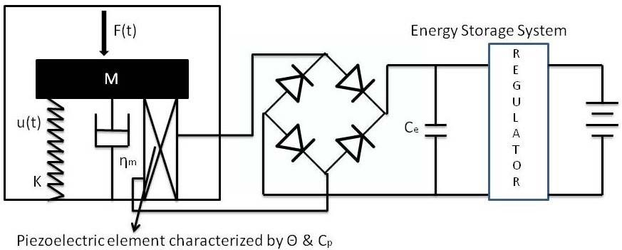

*Source:* Shu and Lien (2006)

## Real life applications of piezoelectric materials

We hypothesised that these piezoelectric materials could be utilised to generate electricity at a place where there is no conventional sources of electricity. As an example, our army soldiers are stationed at high altitude posts like Siachen, Khardungla, Kupwada which are situated between 14,000 and 18,000 feet above MSL where there is no source of electricity.

These are regions of extremely low pressure and temperature. Moreover, the oxygen content in the air is low. The temperature falls below –30°C in peak winter. Soldiers are generally stationed at these locations on an average for two years and face a lot of natural hardships due to the extreme climatic conditions. Due to the harsh climatic conditions, the soldiers have to be covered from head to foot. At some places they also have to carry oxygen cylinders. The frequently occurring problems are frostbite, snow blindness, sunburn. Therefore, there is a need for a portable generator utilising piezoelectric materials that gives enough energy to run microelectronic devices that they use and help them in mitigating the severe conditions. Of all anthropogenic activities, human ambulation (walking) has drawn special interest in the area of energy harvesting. About 67 watts of power is reportedly available from the heel strike (Flynn and Sanders, 2002) of which 5 watts can be extracted by an appropriately shaped piezoelectric insert (Starner et al., 2004).

## Pioneering work

One of the first attempts at investigating the harvesting of energy from human ambulation using piezoelectric materials was by Antaki et al. (1995). Another notable attempt at designing a shoe powered piezoelectric generator was at MIT by Paradiso and Co. In his paper *Parasitic Power Harvesting in Shoes* (1998), Kymissis et al. described the design of a shoe powered piezoelectric generator in which two kinds of piezo materials were used viz PVDF and PZT shown in Figure 3. A PVDF stave was inserted in the insole and a PZT unimorph was inserted into the sole. The average powers produced by the stave and the unimorph were 1 mW and 2 mW respectively with the collective power being enough to power a RF encoder which could be used to give the location of a person.

**Figure 3** Shoe generator designed by Paradiso & Co at MIT, (a) PVDF stave (b) PZT unimorph (see online version for colours)

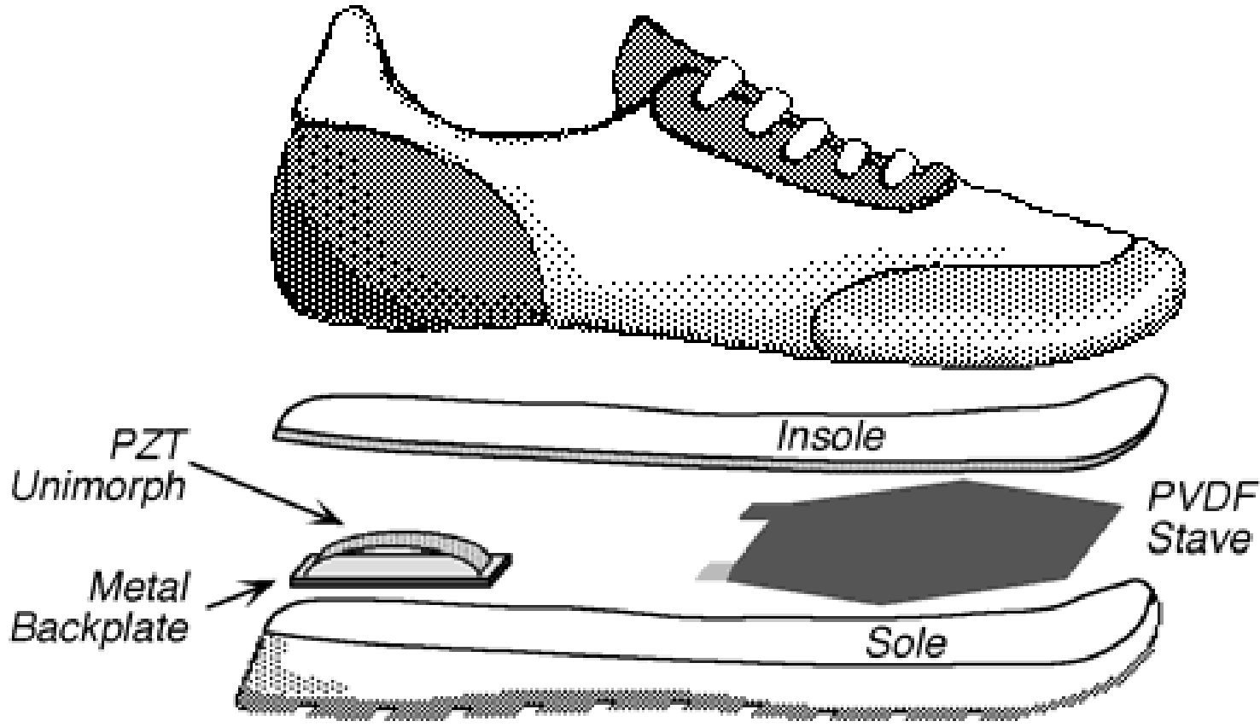

(a)

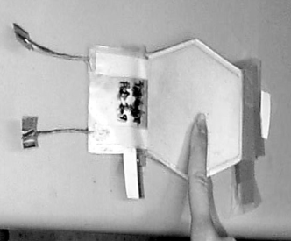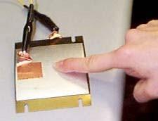

(b)

**Figure 4** PZT bimorph (see online version for colours)

Later, they also designed another piezo generator shoe insert shown in Figure 4. This time it was a bimorph customised using two unimorphs. The average power obtained was

1.8 mW for a vertical displacement of 4.8 mm.

Around the same time, research was also carried out on materials known as electroactive polymers (EAP) or dielectric elastomers (DEE) which demonstrated a similar ability as piezoelectric materials but had a different mechanism. DARPA in collaboration with SRI International designed a shoe generator using such a material which was able to generate 800 mW of power at two steps per second for a heel compression of 3 mm shown in Figure 5. The energy density of this prototype was measured as 0.4 J/gm. The prototype received a patent in 2004 (Pelrine, 2004).

**Figure 5** Shoe generator using EAP/DEE

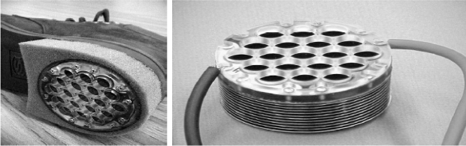

In 2001, well known British inventor Trevor Bayliss trekked the Namibian desert for 100 miles wearing prototype piezo generator shoes developed by the Defense Evaluation Research Agency of the UK Ministry of Defense. This prototype was able to generate about 150 mW of power.

In 2010, McAlpine et al. published a paper in *Nano Letters* describing a method to manufacture flexible nanogenerators. The team fabricated PZT nanofibers and transferred them onto a silicone substrate to get a highly flexible nanogenerator. The advantage of such a generator is that it can be used as a universal, implantable generator. It is flexible and removes the drawbacks due to rigidity and brittleness of PZT sheets. Applications may include implants inside the human body (using lead free materials) to power life support deivices like pacemakers (McAlpine et al., 2010).

Dr. Zhong Lin Wang of the Korea Advanced Institute of Science and Technology in collaboration with Georgia Institute of Technology has made quite a few breakthroughs in flexible nanogenerator technology. Dr. Wang and his team have worked on zinc oxide studying it’s piezoelectric and semiconductive properties. They have fabricated ZnO nanowires, nanobelts, etc. In vivo experiments were conducted by implanting the nanowires into the heart and diaphragm of rats where 30 pA at 3 mV and 4 pA at 2 mV were generated respectively (Wang and Song, 2006).

The next attempt at making a flexible nanogenerator was by Wang et al. appeared in a paper in *Advanced Materials* in June 2012. In this paper a nanocomposite generator (NCG) was fabricated using a simple low cost method. The materials used were barium titanate nanoparticles, carbon nanotubes and silicone. The advantage of the method used besides being simple and low cost is that a large area generator can be fabricated (Wang et al., 2012). NCG is giving consistent output. Outputs with finger compression and foot compression were measured with the outputs being 4 nA at 150 mV and 150 nA at 1.5 V respectively. The prototype was used to charge a capacitor bank which was used successfully to light a LED

**Figure 6** Piezoelectric disc (see online version for colours)

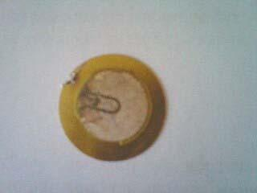

**Figure 7** Piezoelectric ring (see online version for colours)

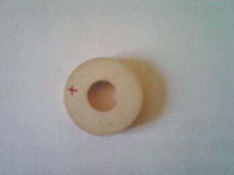

Our recent data show that piezoelectric materials could be utilised to produce electricity. We have tested three types of piezoelectric materials viz. the piezocomposite fabricated inhouse, piezoelectric composite flexural discs (Figure 6) and piezoelectric rings (Figure 7) obtained commercially. The rings and the transducer are of the same material viz. PZT of grade SP 5H (PZT 5H equivalent). The grade SP 5H was particularly selected as it is a soft grade PZT most suitable for low power applications and is commonly used to make sensors and transducers. The discs were obtained from ordinary electrical buzzers.

**Figure 8** A stack of four piezo discs connected in parallel (see online version for colours)

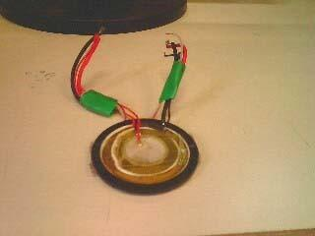

A stack of four piezo discs (two discs were of diameter 3.2 cm and two were of 4 cm) shown in Figure 9 was constructed with the discs connected electrically in parallel. The maximum output current measured across a 100 k resistor was 380 µA. The maximum voltage was about 20 volts (AC).

The following materials were used to fabricate a flexible Piezo composite material:

1. PZT 5 H powder (3 µ and 1 µ particle size)
2. multiwalled carbon nano tubes (MWCNT) (diameter 5–20 nm, length upto 10 µ)
3. polydimethyl siloxane (PDMS) synthetic silicone rubber
4. solvents THF, chloroform

Two types of composites were fabricated. One contained only PZT and PDMS. The other contained MWCNTs in addition to the two components mentioned earlier. Different techniques were used for mixing of the ceramic (PZT) in the polymer (PDMS). To begin with, a composite was made using a shear mixer (muller). 10 gm of PDMS and 1 gm of PZT powder (3 µ) were shear mixed at a rotation speed of 100 rpm in the muller. Curing agent was added to the composite in the ratio 10:1 and the composite was mixed thoroughly. A film was cast using the composite in a Petri dish. It took 24 hrs for the composite to cure fully and transform into a rubber like material.

To reduce the size of the PZT particles, planetary milling was used. Zirconia balls and PZT powder were taken in the ratio of 2:1 and 4:1 by weight and mixed with propanol to form slurry which was enclosed in a pot and milled in the planetary ball mill for 24 hrs. The particle size of the sample removed from the mill after 12 hrs was analysed using a Beckman Coulter Delsa Nano Z particle size analyser. It was found that the particle size decreased from 3 µ to 1 µ. Thereafter, no change in particle size was observed at the end of the milling process.

For the second composition, PZT (1 µ) + CNT + PDMS were mixed in specific percents by weight. The weight percent of PZT in the composite was taken as 9% and 16% in two different compositions. MWCNT was taken in 0.5 wt% and 1 wt% proportions respectively in the two compositions. Two methods were used to mix these materials. Firstly they were mixed in a bottle with zirconia balls using a roller mill for about 24 hours. The composite was then removed and mixed manually with curing agent in the ratio 10:1. It was then cast in a square Teflon mould and allowed to set at room temperature for 24 hrs. The composition mentioned above was again formulated but this time the mixing was done manually. The compositions were cured at room temperature as well as under heat treatment. The cured rubber films ranged in the thickness of 1 mm to 2 mm. They were cut into square pieces of an inch square in size and silvered on one side with silver paste. They were kept aside for 24 hrs at room temperature for the silver paste to cure completely. Then these samples were subjected to corona poling with the silvered surface acting as the ground. The conditions maintained in the corona poling setup were – temperature 70°C and electric field 50–80 kV. The poling was carried out for about 30 min with the hot plate in the setup switched off after about 20 min and the electric field kept on. The samples were removed and kept aside for a few minutes. The second sides of the samples were then silvered and they were kept aside for another 24 hrs at room temperature. The next day the samples were tested for piezoelectric constant values using a Piezotest PM300 d33 meter. No significant values were observed. Electrically conductive copper tapes (by Klim Enterprises, Vasai, Maharashtra, India) of thickness 50 µ were adhered to both sides of the samples to act as leads. The samples were also tested with a DSO to check for any voltage generated. But no significant signals were observed. However, upon testing with a digital multimetre, a peak AC voltage of around 300 mV was observed indicating that the material had some piezoelectric property.

## 4. Simple Demonstration -

This research paper is based on the generation of electricityby mechanicalvibrations done while walking. When aperson wearing shoes walk on floor, the exerted stress isconverted into electrical energy throughpiezoelectric transducers [39]. The generated energy by the piezoelectricdisk in the in tile is directly proportional to the mechanicalvibration, that is the more the pressure (weight) or forceexerted onto the disk at one time, the higher the output. So,research was done to find out which parts of the floor tilereceives the greatest amount of appliedmechanical pressure.When a person walks and it was seen that those parts werethe front and the back parts of the tile planted on the floor.When the pressure is applied on the piezoelectric disks frominside the foot, mechanical energy isgenerated.Thismechanical energy is converted into electrical impulses bythe piezoelectric transducers. The electric voltage generateddue to a potential difference of the charges, is an AC voltage(due to variations in vibrations resulting due to differentamount of pressure applied), therefore a bridge rectifiercircuit is used which converts the AC voltage into DCvoltage so that it could be used in electronic devices. directconnection of a battery to a rectifier results in a constant VRECand that is an inefficient energy harvester. So, to increase theharvesting power of the circuit, a DC-DC power converter ifadded to the circuit to adaptively adjust the rectified voltagewith respect to the piezoelectric open-circuit voltage (VOC)[40]. A structural outline of all the processes occurring in oursetup is splendidly shown in Figure

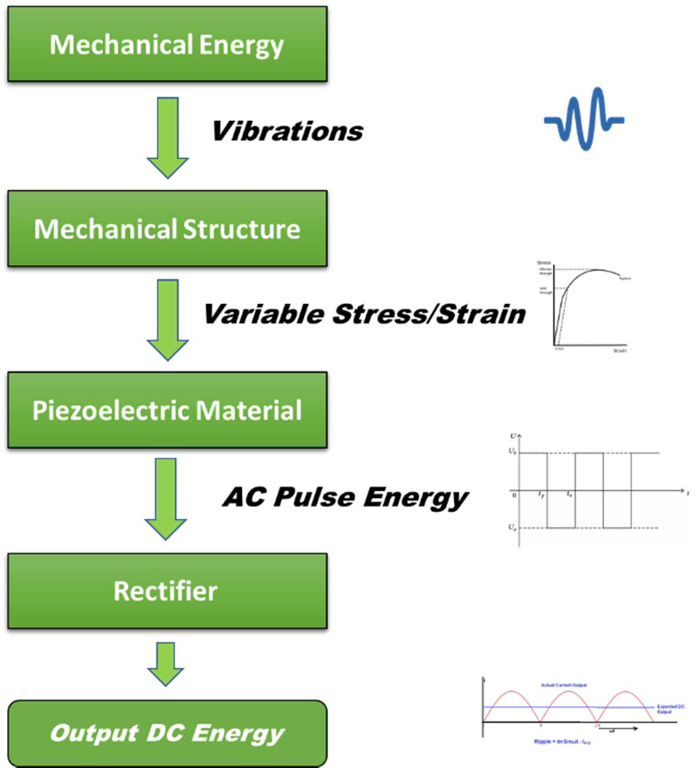

In order to practically perform our idea of harvesting energythrough piezoelectric material, the modeling for betterenergy extraction is explained for shoe energy utilization byPramit Saha et.al. [41]. In our proposed prototype we used a1.5-1.5 feet tiles in which 35mm piezoelectric transducersare used. The transducers are coated on top with a 7-8mmpolystyrene. The nominal voltage, a single transducer giveswith polystyrene on pressure implication is around 8-10volts. Accordingly, eight transducers give around 60-64volts. But we just got 15-16 volts from a single seriesconnection of eight transducers. Also, it is the fact thatparallel connection increases the current [1] to a great extent.Initially we pressed the discs with our thumbs but desiredvoltage readings were not obtained. So, we put polystyreneon top of the disc and then our desired voltagreadings wereobtained. We decreased the thickness of the polystyreneseveral times until we got an ideal thickness of 7-8 mm. Weconnected eight transducers in series and joined such eightcombination in parallel as shown in The video demonstration will also help to clear the proposed idea [42].

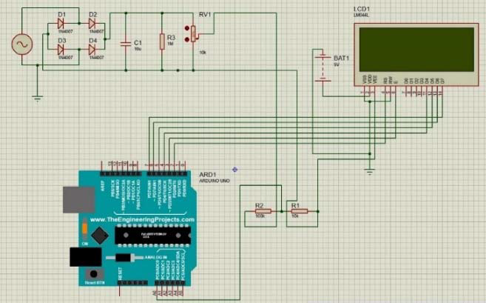

## 5. Conclusions

This research paper best describes a reliable and dynamic model for harvest piezoelectric energy. The experimental results sensibly validate our harvesting technique. This approach can make every footstep usable and is highly preferable as it is cost-efficient, easily applicable, and user-friendly too. The proposed energy-harvesting circuitry can notably increase the extracted power from the piezoelectric element directly connecting a battery to the piezoelectric rectifier. The overall efficiency is predominantly determined by its switching circuit since the controller power loss is negligible as compared with the switching loss

ref-at: https://www.researchgate.net/publication/338797132

## Acknowledgements

We would like to sincerely thank Dr. Pradeep K Naik, Associate Professor of the Bioinformatics Department, Jaypee University of Information technology, Waknaghat, Solan who inspired us to do this work. We also thank Mr. Subrat Sahu, STA, Ceramics Division, NMRL for extending all the technical help in carrying out the experiments at NMRL. In addition, our sincere gratitude goes out to Dr. Sunil Kumar Hota, Scientist D, Experimental Biology Division, DIHAR, DRDO for his invaluable inputs and DIHAR DRDO for their financial support and suggestions.

## References

Antaki, J.F. et. al. (1995) ‘A gait powered autologous battery charging system for artificial organs’,

*ASAIO Journal*, July–September, Vol. 41, No. 3, pp.M588–M595.

Flynn, A.M. and Sanders, S.R. (2002) ‘Fundamental limits on energy transfer and circuit considerations for piezoelectric transformers, *IEEE Transactions on Power Electronics*, Vol. 17, No. 1, pp.8–14.

<http://en.wikipedia.org/wiki/Energy_harvesting> (accessed 12 June 2014).

<http://sroeco.com/solar/most-efficient-solar-panels> (accessed 15 June 2014).

Kymissis, J., Kendall, C., Paradiso, J. and Gershenfeld, N. ‘Parasitic power harvesting in shoes’, *Wearable Computers, 1998. Digest of Papers. Second International Symposium*, 19–20 October 1998, Pittsburgh, PA, USA, pp.132–39.

McAlpine, M.C. et al. (2010) ‘Piezoelectric ribbons printed onto rubber for flexible energy conversion’, *Nano Lett*., Vol. 10, No. 2, pp.524–528, McAlpine & Co.

Paradiso, J.A. and Starner, T. (2005) *Energy Scavenging for Mobile and Wireless Electronics*, Vol. 4, No. 1, pp.18–27, IEEE CS and IEEE ComSoc, 1536-1268/05/$20.00 © IEEE.

Pelrine , R.E. (2004) *Heel Strike Generator Using Electrostrictive Polymers*, Patent number: 6768246, Issue date: 27 July.

Roundy, S. and Wright, P.K. (2004) ‘A piezoelectric vibration based generator for wireless electronics’, *Roundy, Wright, Smart Mater. Struct*, Vol. 13, No. 5, pp.1131–1142.

Shu, Y.C. and Lien, I.C. (2006) ‘Efficiency of energy conversion for a piezoelectric power harvesting system’, *Journal of Micromechanics and Microengineering*, Vol. 16, No. 11, pp.24–29.

Starner, T., Paradiso, J.A. and Piguet, C. (Ed.) (2004) ‘Human generated power for mobile electronics’, Venue: *Low Power Electronics Design*, Venue Type: Conference, pp.1–35, Vol. 45, CRC Press.

Wang, Z.L. and Song, J. (2006) ‘Piezoelectric nanogenerators based on zinc oxide nanowire arrays’, *Science*, 14 April, Vol. 312, No. 5771, pp.242–246.

Wang, Z.L. et al. (2012) ‘Flexible nanocomposite generator made of BaTiO3 nanoparticles and graphitic carbons’, *Adv. Mater*, 12 June, Vol. 24, No. 22, pp.2999–3004, 293.